ISLAMIC UNIVERSITY OF TECHNOLOGY

Organization of Islamic Cooperation

Board Bazar, Gazipur

Laboratory Report

CSE 4512

**Title**: Configuring Switch Port Analyzer (SPAN) in Cisco Devices

**Objective**:

* Describe the concept of port mirroring
* Implement port mirroring using Cisco Switch Port Analyzer (SPAN)

**Devices/Software Used**: Cisco Packet Tracer

**Theory**:

Port Mirroring: It is possible to configure a switch so that all the data going into and out of one port is copied and sent out a different port. This process is called Port Mirroring.

Local SPAN: In Cisco devices, port mirror is achieved using the Switchport Analyzer, called SPAN in short. Port mirroring can be applied in situations where the source and destination ports are on the same switch or on different switches. The prior case is called Local SPAN.

**Diagram of the experiment(s)**:

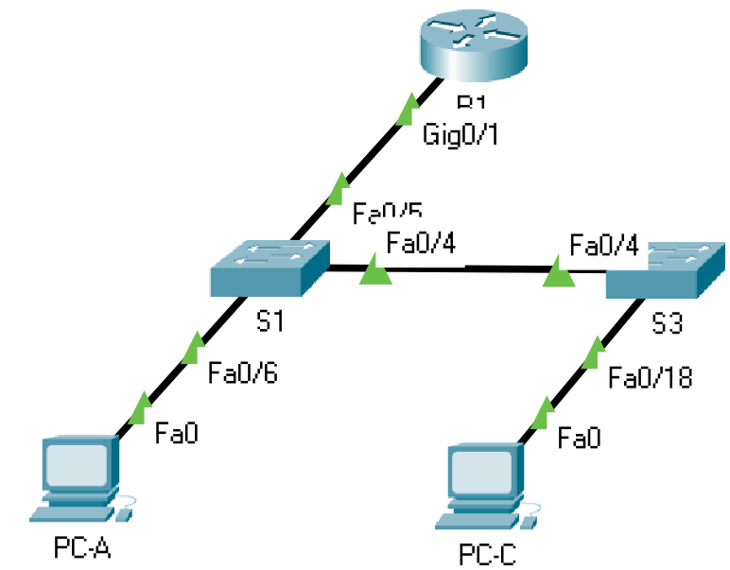

**Working Procedure**:

1. The network was set up as shown in the diagram above.
2. The PC hosts were configured.

PC-A:

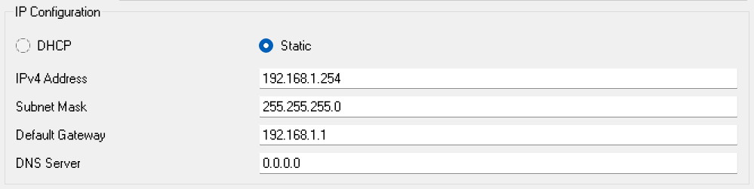

PC-C:

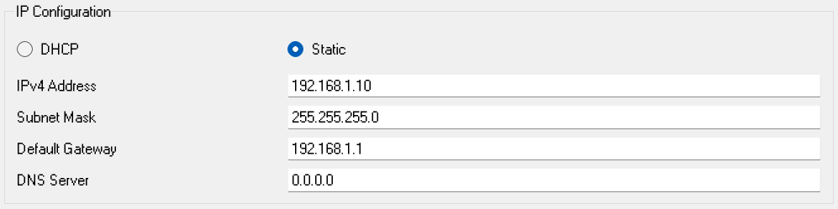

1. The basic settings for R1 were configured:

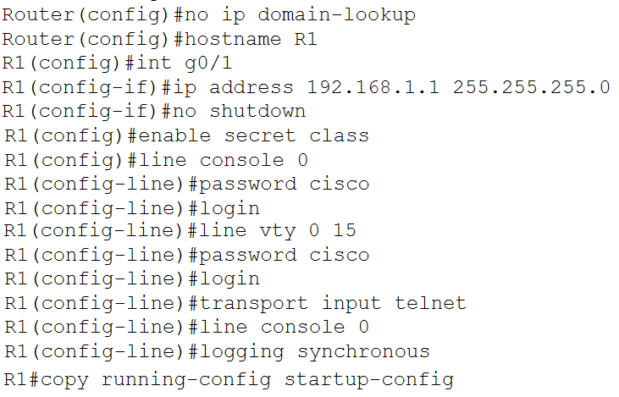

1. The basic settings for each switch were configured:

S1:

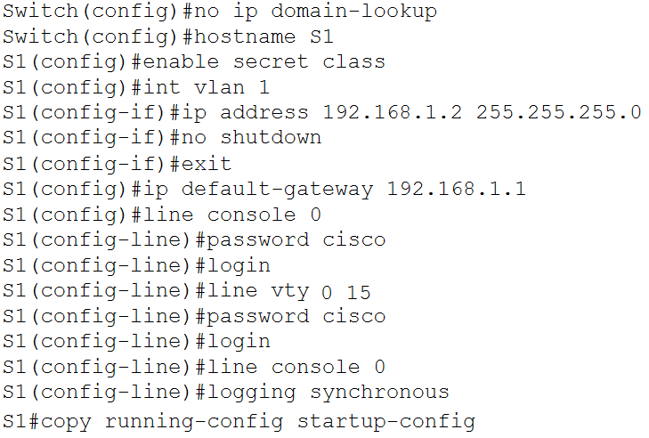

S3:

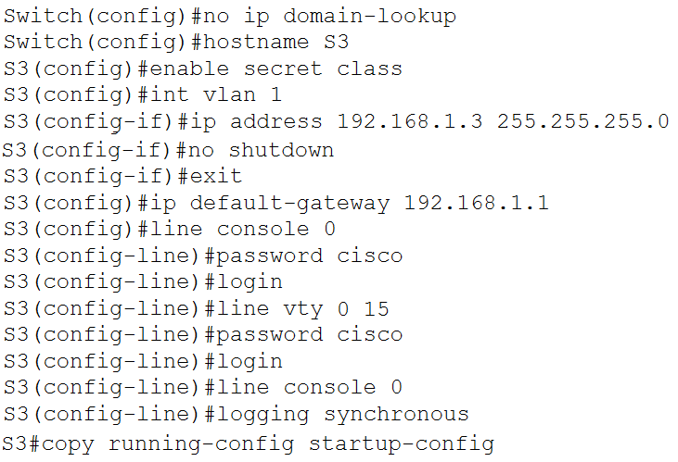

1. Connectivity was verified.

From PC-A to R1:

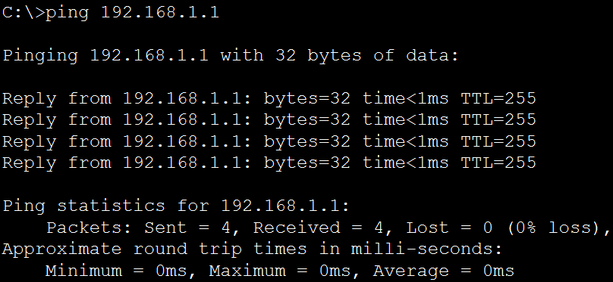

From PC-A to S1:

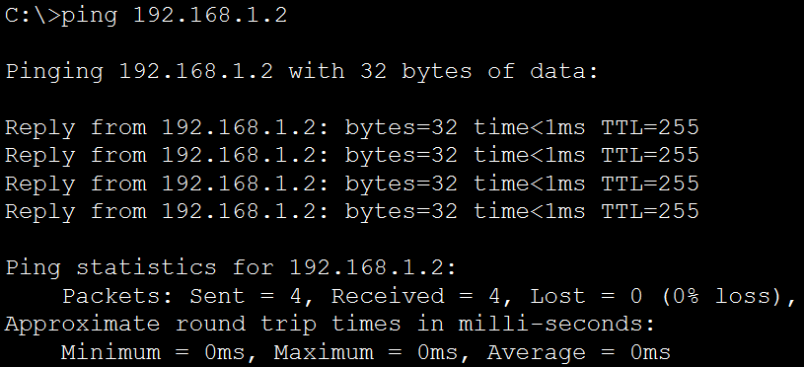

From PC-A to S3:

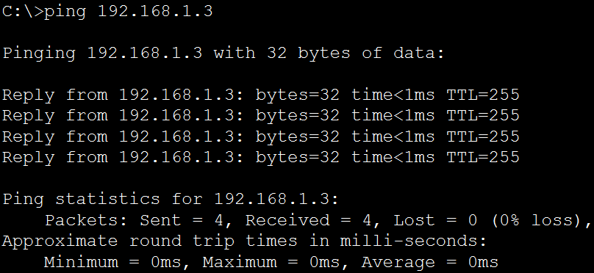

From PC-A to PC-C:

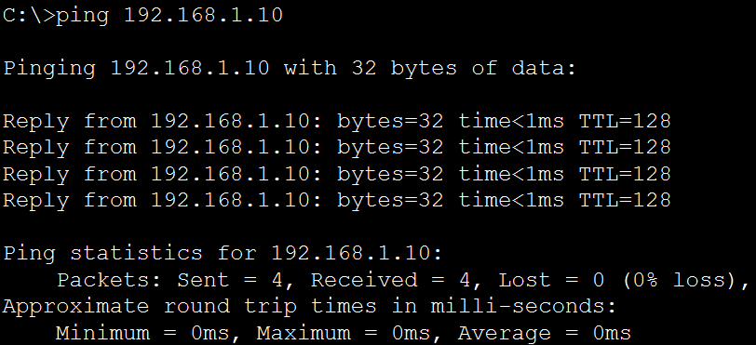

From PC-C to R1:

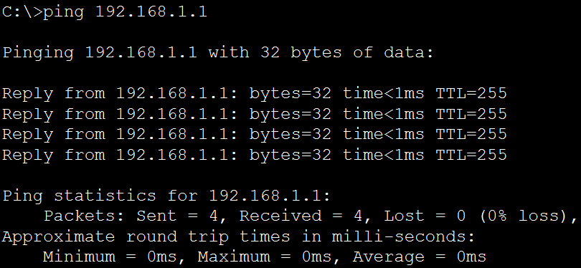

From PC-C to S1:

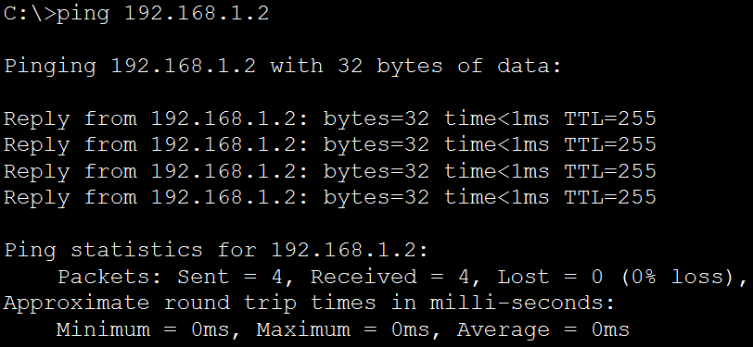

From PC-C to S3:

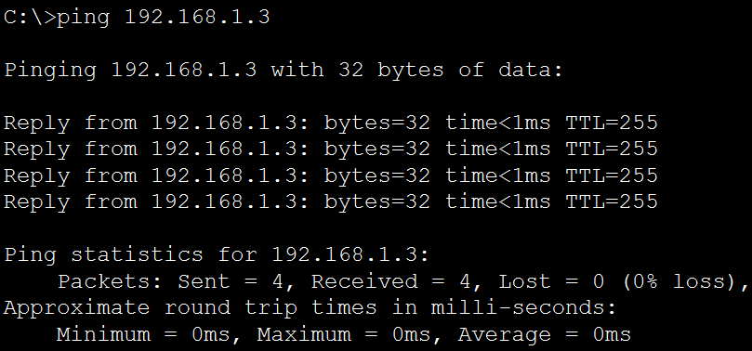

From PC-C to PC-A:

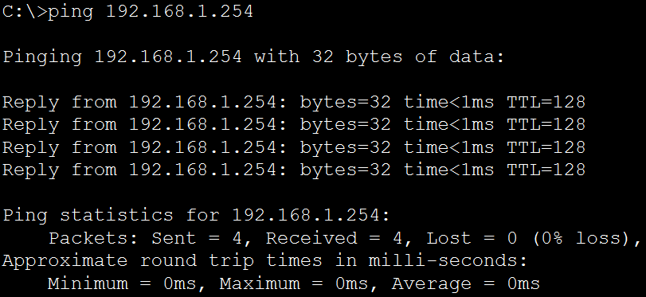

1. Configured SPAN on S1:



1. Opened the Simulation window with just the ICMP filter.

From S1, telnet into R1 to create ICMP traffic:

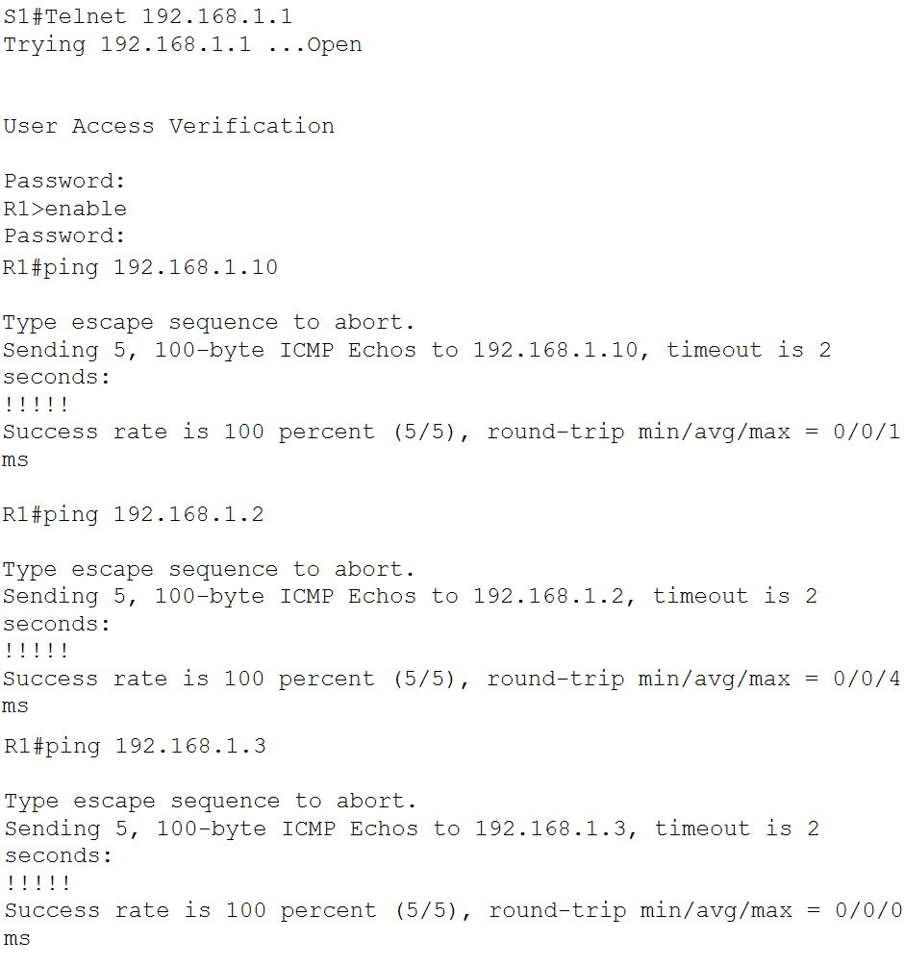

**Questions**:

Task # 01:

Question: From PC-A, you should be able to ping the interface on R1, S1, S3, and PC-C. Were all pings successful??

Answer: Yes.

Question: From PC-C, you should be able to ping the interface on R1, S1, S3, and PC-A. Were all pings successful?

Answer: Yes.

Question: Were the pings from R1 to PC-C, S1 and S3 successfully copied and forwarded out f0/6 to PC-A?

Answer: Yes.

Question: Was the traffic monitored and copied in both directions?

Answer: Yes.

**Challenges**:

The logging synchronous command was new and it required some research to figure out how to implement it.